Operating Systems Lab
L39+L40
SJT418

Assignment 1

Namit Nathwani
17BCI0113
QUESTION 1:
Linux commands which you have practiced/worked (minimum of 20 Commands with he following:
Syntax of the command
Usage of the command and the output(screenshot)

QUESTION 2:
Any four C programs of your choice with program and output(screenshot) which uses conditional, looping statements.

Write a program to do matrix operations (add, subtract, multiply)
#include <stdio.h>
int main() {
int ch = 1, i, j, k;
int a[3][3], b[3][3], c[3][3];

printf("Enter the first matrix, row-wise\n");
for(i = 0; i < 3; i++)
for(j = 0; j < 3; j++)
scanf("%d", &a[i][j]);

for(i = 0; i < 3; i++) {
for(j = 0; j < 3; j++)
printf("%d\t", a[i][j]);
printf("\n");
}

printf("Enter the second matrix, row-wise\n");
for(i = 0; i < 3; i++)
for(j = 0; j < 3; j++)
scanf("%d", &b[i][j]);

for(i = 0; i < 3; i++)
for(j = 0; j < 3; j++)
c[i][j] = 0;

do {
printf("Enter choice: \n1 - Add\n2 - Subtract\n3 - Multiply");
scanf("%d", &ch);
switch(ch) {
case 1:
for(i = 0; i < 3; i++)
for(j = 0; j < 3; j++)
c[i][j] = a[i][j] + b[i][j];

printf("Result = \n");
for(i = 0; i < 3; i++) {
for(j = 0; j < 3; j++)
printf("%d\t", c[i][j]);
printf("\n");
}
break;

case 2:
for(i = 0; i < 3; i++)
for(j = 0; j < 3; j++)
c[i][j] = a[i][j] - b[i][j];

printf("Result = \n");
for(i = 0; i < 3; i++) {
for(j = 0; j < 3; j++)
printf("%d\t", c[i][j]);
printf("\n");
}
break;

case 3:
for(i = 0; i < 3; i++) {
for(j = 0; j < 3; j++) {
for(k = 0; k < 3; k++)
c[i][j] += a[i][k] * b[k][j];
}
}

printf("Result = \n");
for(i = 0; i < 3; i++) {
for(j = 0; j < 3; j++)
printf("%d\t", c[i][j]);
printf("\n");
}
break;

default: ch = 9;

}
//break;
} while(ch != 9);
}

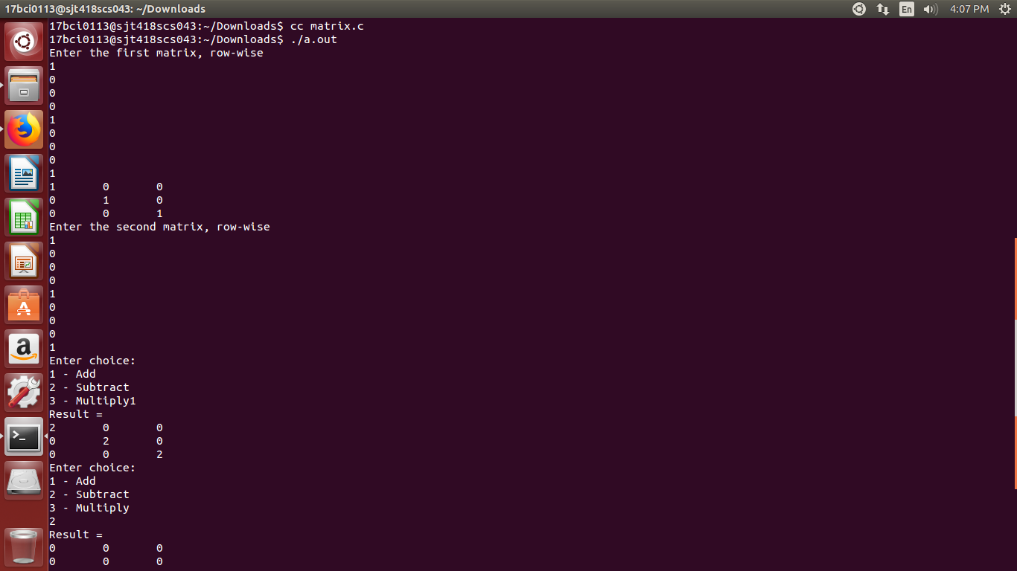

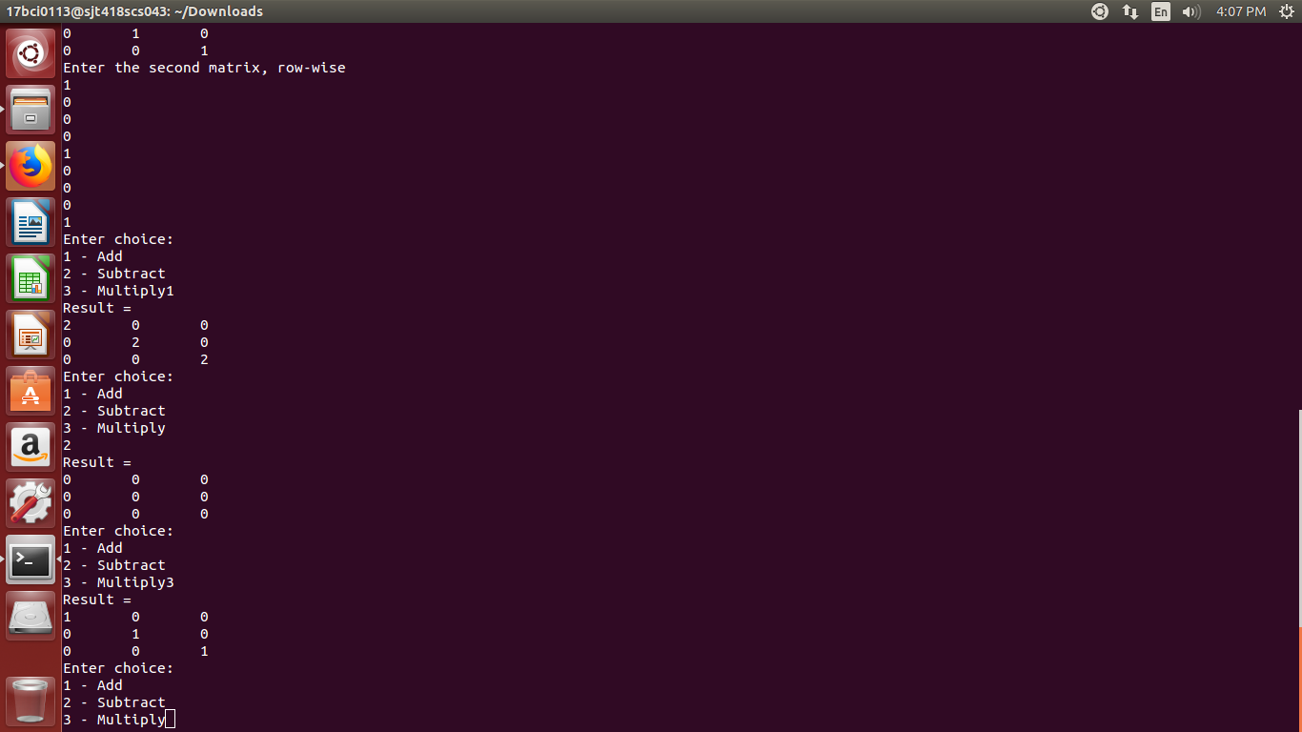
Write a program to find the greatest of three numbers
#include<stdio.h>
int main() {
int a, b, c;
printf("Enter three numbers\n");
scanf("%d", &a);
scanf("%d", &b);
scanf("%d", &c);

if(a >= b && a >= c)
printf("\nA is greatest\n");
else if(b >= a && b >= c)
printf("\nB is the greatest\n");
else if(c >= a && c >= b)
printf("\nC is the greatest\n");
}

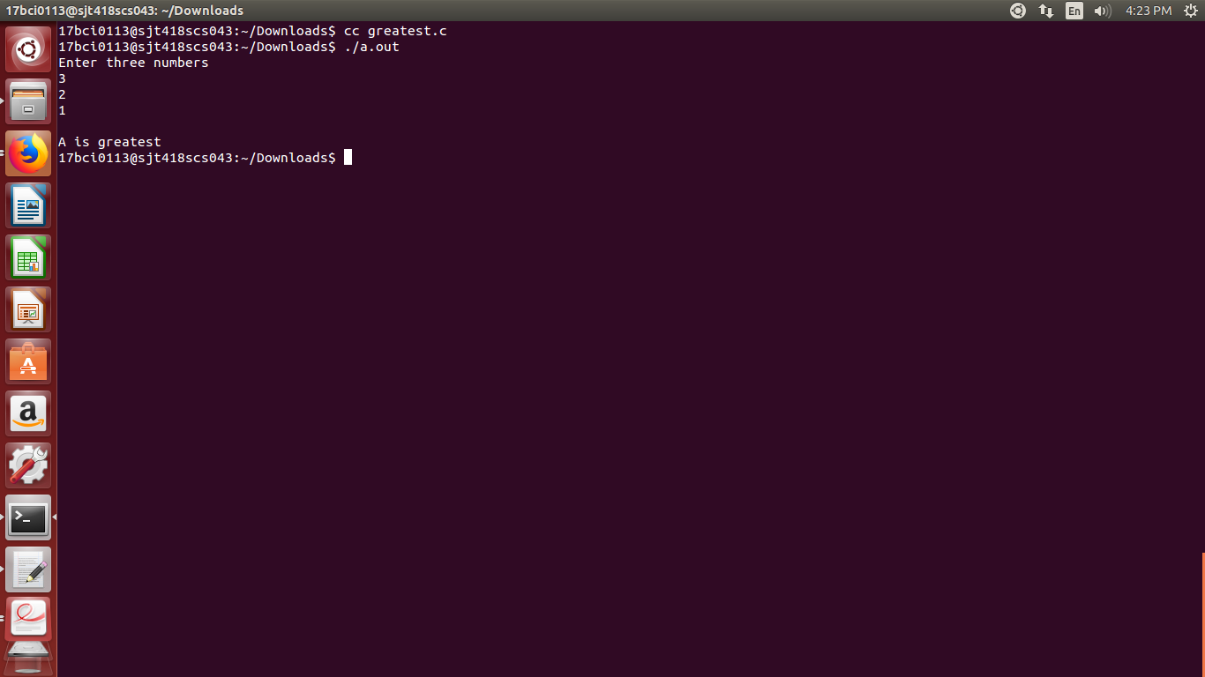

Write a program to find reverse of a number
#include<stdio.h>
int main() {
int n, rev, i;

printf("Enter number to reverse\n");
scanf("%d", &n);

rev = 0;

for(i = n % 10; n > 0; n = n / 10, i = n % 10) {
rev = rev * 10;
rev = rev + i;
}

printf("\nReverse Number: %d\n", rev);
}

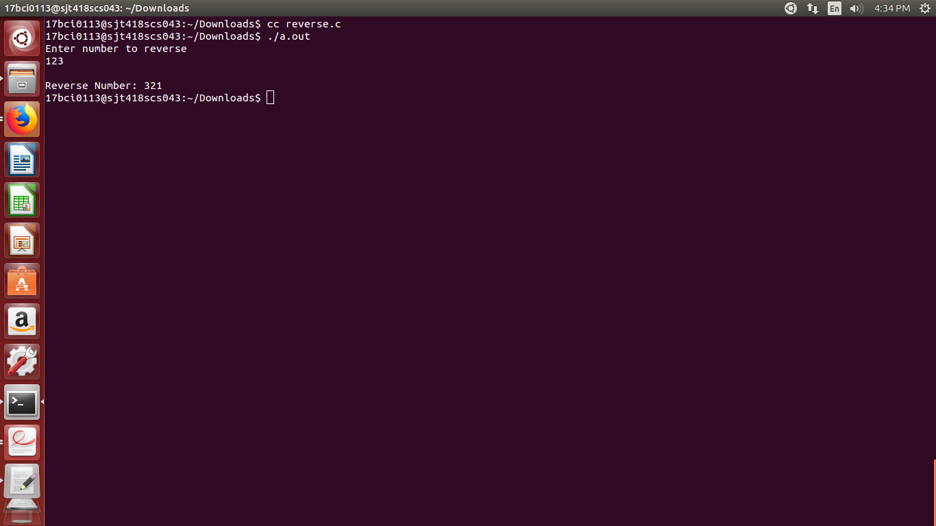

Write a program to print a pyramid of *
#include<stdio.h>
int main() {
int n = 5, i, j;
for(i = 0; i < n + 1; i++) {
for(j = 0; j < i; j++)
printf("*");
printf("\n");
}
}

